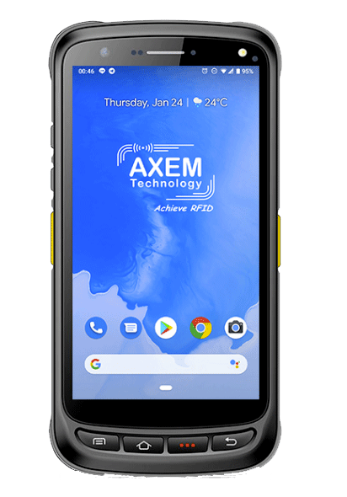

MBA5-P20 V8
User guide

Table of content
1 Background 2
2 Product introduction 3
2.1 Introduction 3
2.2 Precaution before using battery 4
2.3 Charger 4
2.4 Notes 5
3 Installation instructions 6
3.1 Appearance 6
3.2 Install Micro SD and SIM cards 6
3.3 Battery Charging 6
3.4 Buttons and Function Area 6
4 Call function 8
4.1 Calling numbers 8
4.2 Contacts 8
4.3 SMS and MMS 8
5 NFC reader 9
5.1 Read functionality 9
5.2 Write functionality 10
6 Other functions 11
6.1 Bluetooth 11
6.2 GPS 12
6.3 Volume setup 13
6.4 Sensor 14
6.5 Keyboard 15
6.6 Network 16
6.7 Infrared read-write function (option) 17
6.8 Developing Environment 18
6.9 Accessories 18

Background
Description | Date | Version | Author | Auditor
First parution | 01/04/2021 | V1.0 | CLO

Product introduction

Introduction

The MBA5-P20 V8 is a smart mobile PDA integrating many data capture modules including NFC/HF. It fits to many industrial applications to track materials.
The device runs under 8.1 Marshmallow Android operating system.
With a 5″ FHD touchscreen that offers reading comfort, the smartphone can be used with wet hands or gloves. Moreover, it has a 1.3 GHz quadcore processor, a high power that will allow a fast data processing.
It also has Wireless communication: 4G/LTE, Wifi, Bluetooth, GPS.
With IP65 protection grade, it is totally protected against dust and is waterproof.

Precaution before using battery

- Do not leave battery unused for long time, no matter it is in device or inventory. If battery has been used for 6 months already, it should be check for charging function or it should be disposed correctly.

- The lifespan of Li-ion battery is around 2 to 3 years, it can be circularly charged for 300 to 500 times. (One full battery charge period means completely charged and completely discharged.)

- When Li-ion battery is not in used, it will continue discharge slowly. Therefore, battery charging status should be checked frequently and take reference of the related battery charging information on the manuals.

- Observe and record the information of a new unused and non-fully charged battery. On the basis of operating time of new battery and compare with a battery that has been used for long time. According to product configuration and application program, the operating time of battery would be different.

- Check battery charging status at regular intervals.

- When battery operating time drops below about 80%, charging time will be increased remarkably.

- If a battery is stored or otherwise unused for an extended period, be sure to follow the storage instructions in this document. If you do not follow the instructions, and the battery has no charge remaining when you check it, consider it to be damaged. Do not attempt to recharge it or to use it. Replace it with a new battery.

- Store the battery at temperatures between 5 °C and 20 °C (41 °F and 68 °F)

Charger
The charger type is GME10D-050200FGu, output voltage/current is 5V DC/2A. The plug considered as disconnect device of adapter.

Notes

Note 1:
Using the incorrect type of battery has danger of explosion. Please dispose the used battery according to instructions.

Note 2:
Due to the used enclosure material, the product shall only be connected to a USB Interface of version 2.0 or higher. The connection to so called power USB is prohibited.

Note 3:
The adapter shall be installed near the equipment and shall be easily accessible.

Note 4:
The suitable temperature for the product and accessories is 10℃ to 50℃.

Note 5:
CAUTION RISK OF EXPLOSION IF BATTERY IS REPLACED BY AN INCORRECT TYPE. DISPOSE OF USED BATTERIES ACCORDING TO THE INSTRUCTIONS.

Installation instructions

Appearance

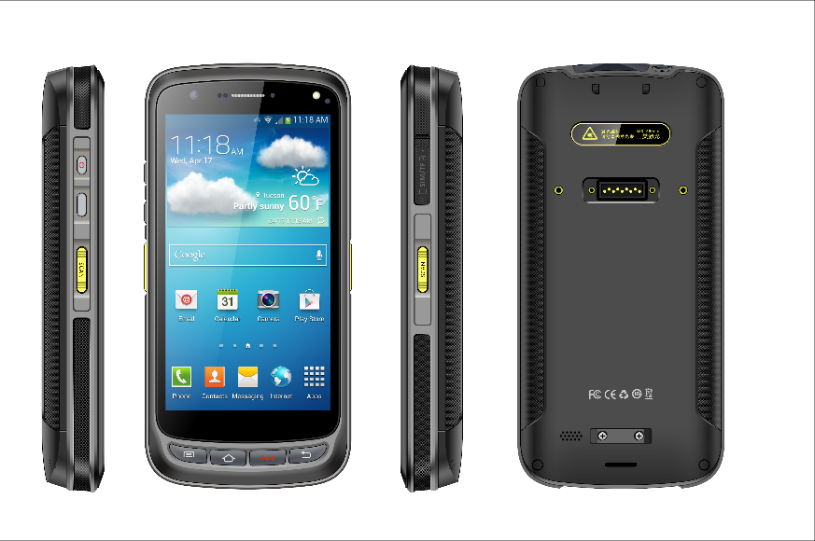

Install Micro SD and SIM cards

The cards sockets are showing as follows:
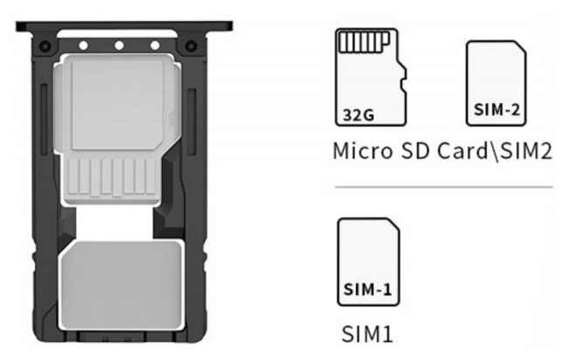

Battery Charging

By using USB Type-C contact, the original adaptor should be used for charging the device. Make sure not to use other adaptors to charge the device.

Buttons and Function Area

4
5
6
7

1
2
3

Buttons instructions
Side button | 1 | Power | Located on left side, press to ON/OFF device.
 | 2 | Function key | Located on left side, its function can be defined by software.
 | 3 | SCAN button | Scanning button located on both sides. There are two scanning buttons.
Main button | 4 | Menu | Display main menu.
 | 5 | Home | Touch it back to main screen.
 | 6 | Enter | Press to confirm current selection
 | 7 | Backspace | Return to last step to setup.

Call function

Calling numbers

1. Click icon .
2. Click number key to input phone numbers.
3. Click icon to call.
4. Click icon 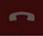 to end call.

Contacts

1. Click contacts to open contacts list.
2. Click icon 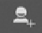 to add new contacts.
3. Click icon to import/export contacts.

SMS and MMS

1. Click to open message window.
2. Click 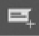 to input message receiver and contents.
3. Click to send out messages.
4. Click to add attachment pictures and videos.

Barcode reader-writer
In App Center, open 2D barcode scan test.
Press “SCAN” button or click scan key to start scanning.
The parameter “Auto interval” can be adjusted.
In the tab CONFIG, parameters numbers and values can be adjusted. Moreover, illumination power level can be adjusted from 0 to 10.
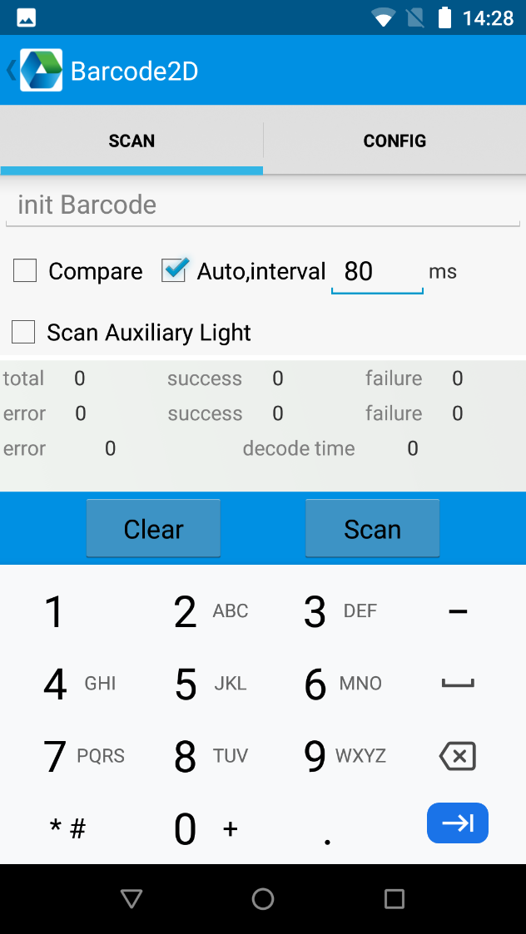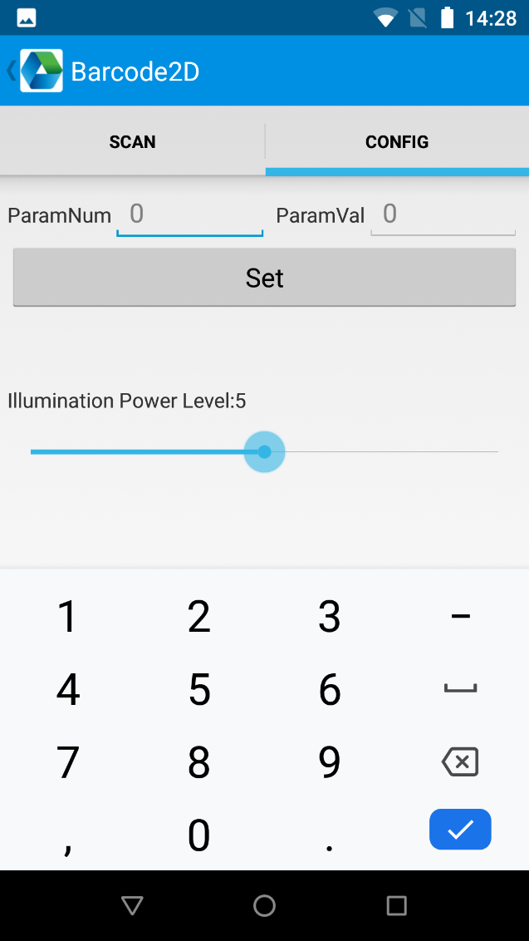

Caution: Please scan codes in correct way otherwise the scanning will be failed.
1D barcode:
2D barcode:

Max. radiant power: 0.6mW
Wave length: 655nm
IEC 60825-1 (Ed.2.0). 21CFR 1040.10 and 1040.11 standard.

NFC reader

Read functionality

- Click App Center, open “NFC” to read tag information.

- Place the tag you want to read in front of the RFID antenna as shown below:
Photo

- The tag will be read.
You can also select a text zone to read the tag. It is not needed to open the application since the device is equipped with keyboard emulation.

Write functionality

The storage of one tag has 4 zones: RESERVED, EPC, TID and USER. Normally, the default password is 00000000. And TID zone can only be read, other zones can be read and written.
- Click App Center, open “NFC” to write information in the tag.

- Place the tag in front of the RFID antenna.

- Write information in the tag by using the keypad as shown below:
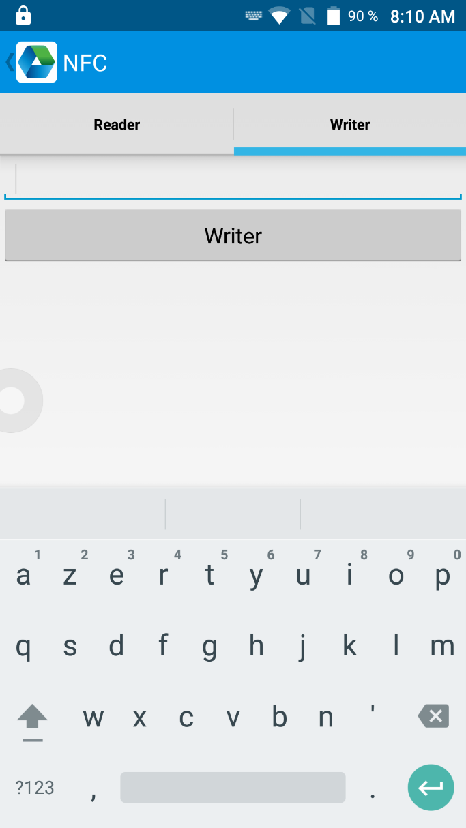

Other functions

Bluetooth

1. Open “BT Printer” in App Center.
2. In the list of detected devices, click the device that you want to pair.
3. Select printer and click “Print” to start printing contents.
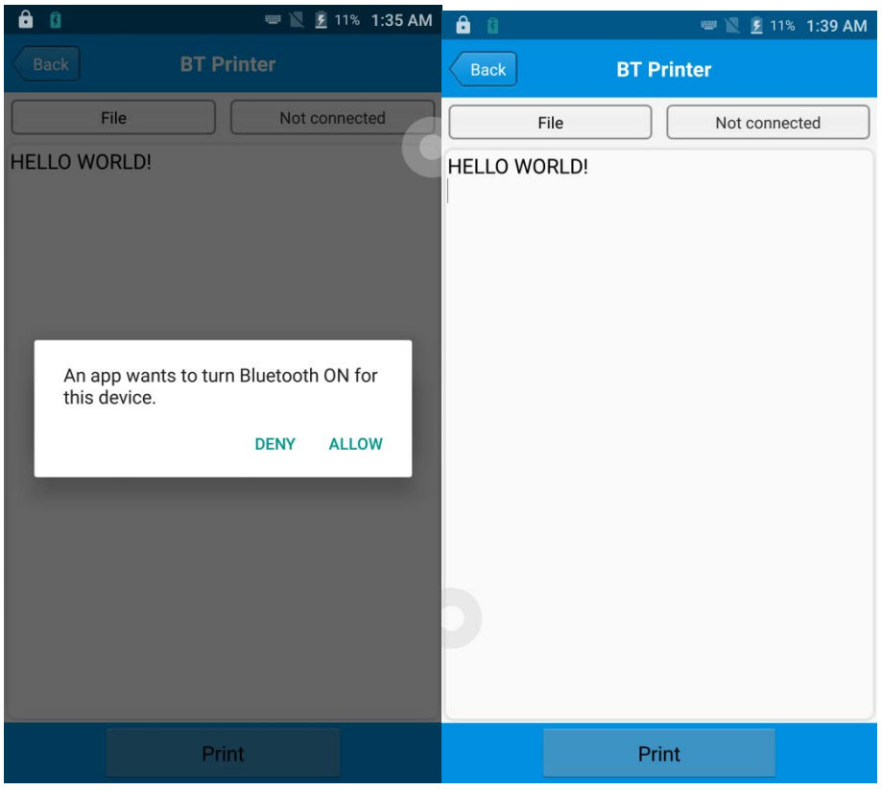

GPS

1. Click “GPS” in App Center to open GPS test.
2. Setup GPS parameters to access GPS information.
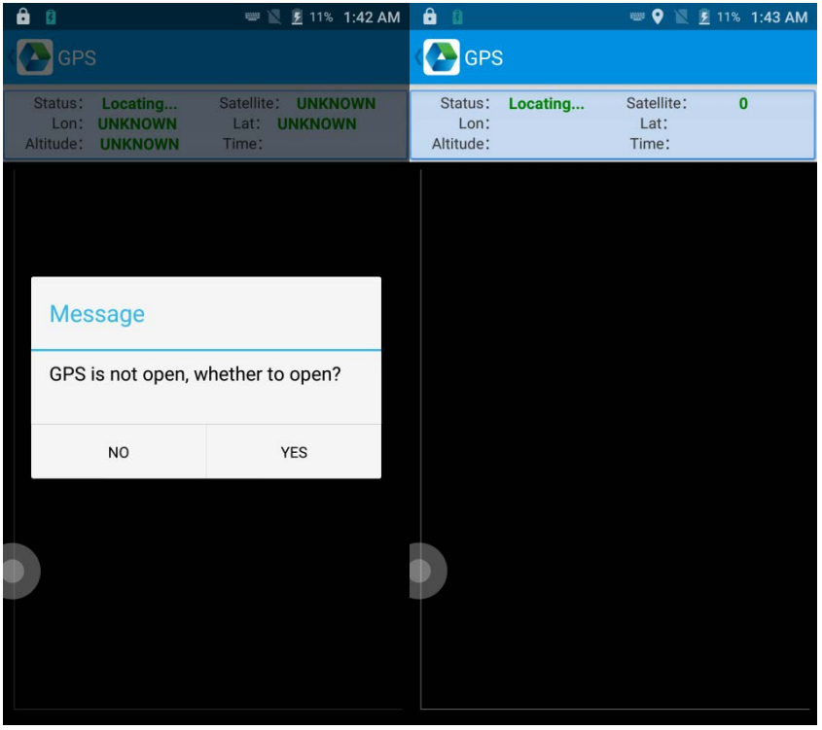

Volume setup

1. Click “Volume” in App Center.
2. Setup volume by requirements.
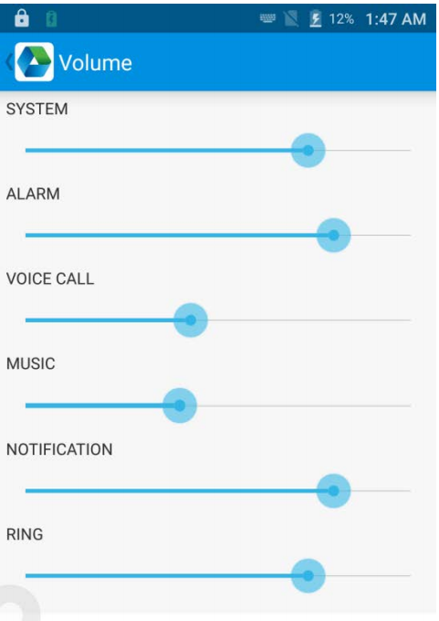

Sensor

1. Click “Sensor” in App Center.
2. Setup the sensor by requirements.
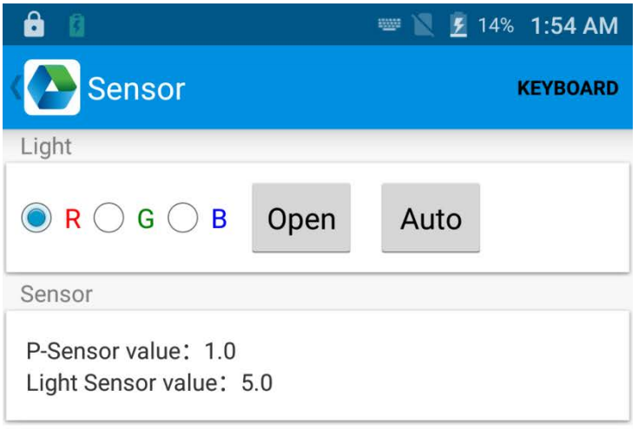

Keyboard

1. Click “Keyboard” in App Center.
2. Setup and test the main value of the device.
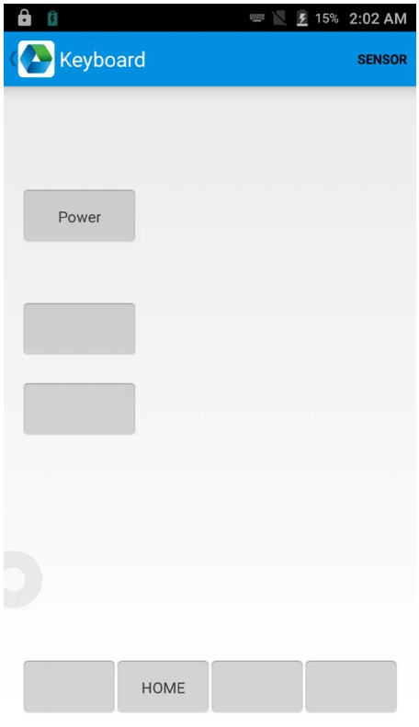

Network

1. Click “Network” in App Center.
2. Test WIFI/Mobile signal by requirements.
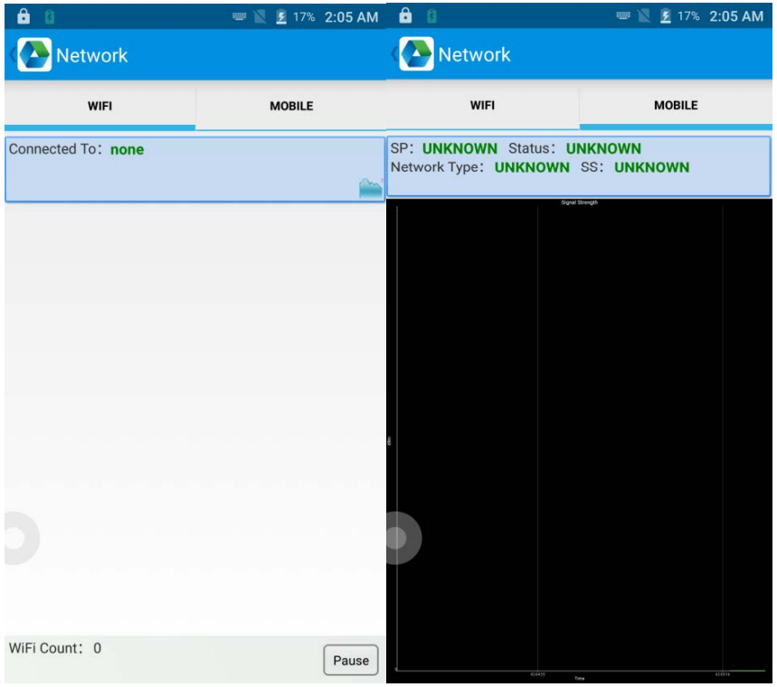

Infrared read-write function (option)

1. Open infrared function in App Center.
2. Click button “Open” to start infrared scanning function. Click “LED” for infrared scanning aim assist. Depending on different application status to compile different commands to realize infrared read and write function.
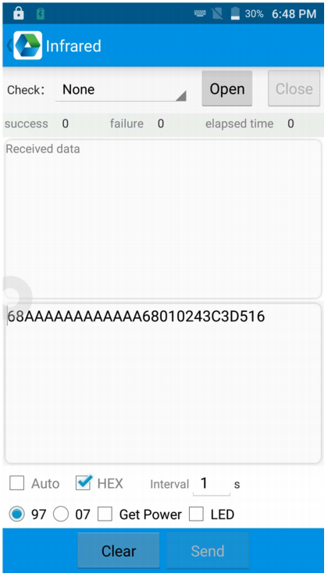

Developing Environment

Accessories
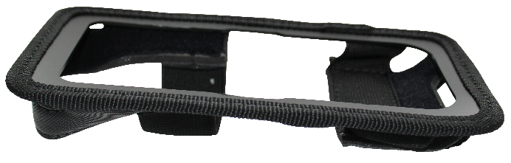
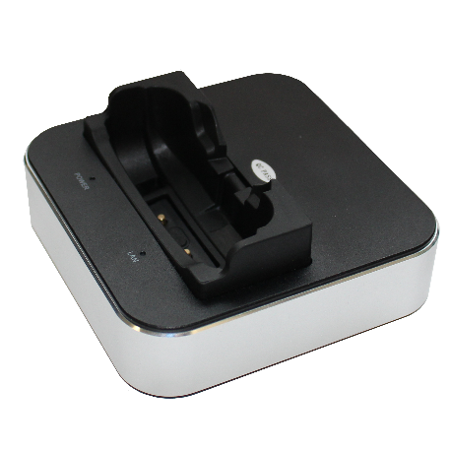
Holster Cradle

