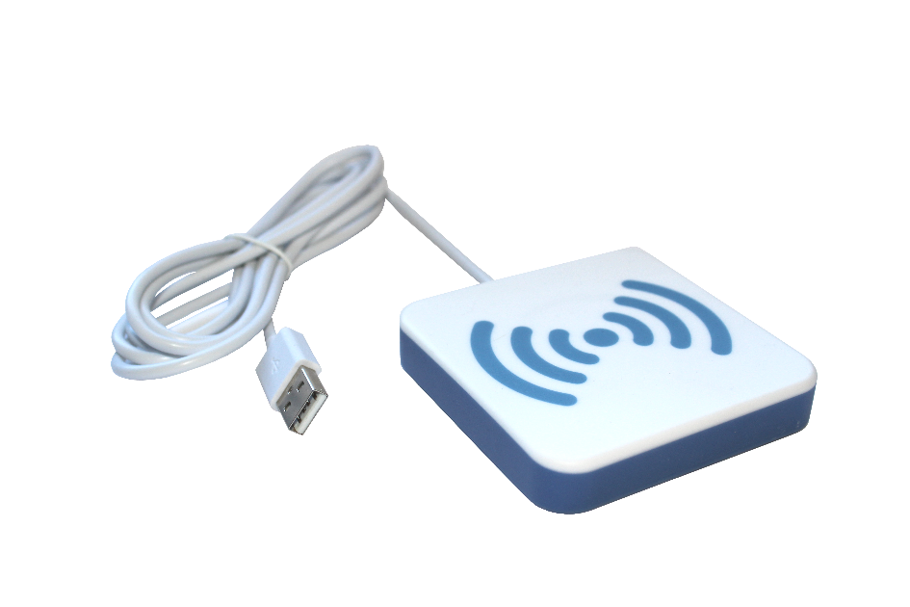

Quick start user guide
YOU reader

Table des matières
1 Introduction 4
1.1 First time use 4
1.2 Understanding the LEDs and the beeper 4
2 Reader configuration 5
2.1 YOU reader in keyboard emulation 5
2.1.1 1What is keyboard emulation? 5
2.1.2 How it works 5
2.2 YOU reader in PC/SC mode 5
2.2.1 What is PC/SC mode? 5
2.2.2 How it works 5

Background

Description | Date | Version | Author | Auditor
First parution | 01/04/2021 | V1.0

Introduction
The YOU reader is a contactless reader that can read NFC/RFID cards @13.56MHz. It can be used in keyboard emulation or in PC/SC. This configuration can be requested when ordering the reader from AXEM Technology.
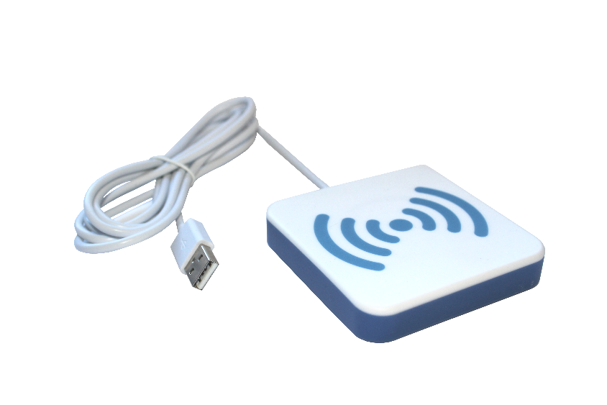

First time use
Connect the YOU reader to one of the USB ports on your computer.
Wait 10 to 20 seconds until the operating system turns on the reader driver and activates the reader.
The first time you connect the reader, it may take a few seconds to activate or download drivers. This is normal.
After that, the coupler device will be activated within a few seconds.
Watch the LEDs on the device. As soon as the cyan light enters a "periodic on/off" sequence, the device is ready!

Understanding the LEDs and the beeper
LED and Bips | Description
Blue LED | The device is ready and waiting for a contactless card.
Unique Bip + green LED | A contactless card is present and available for operation.
Repeted bips | The communication between the device and the card is not reliable. Place the card closer to the device. Install the device in a different location.
Red LED, flashing | Problem (hardware error or overheating).
Yellow LED, flashing | The PC has not yet activated the device.

Reader configuration
The reader can be configured in keyboard emulation or in PC/SC. This configuration can only be executed by AXEM Technology and cannot be modified.

YOU reader in keyboard emulation

1What is keyboard emulation?
This means that the reader is viewed as a keyboard by your computer.

How it works
To use the reader in keyboard emulation, you may open a spreadsheet or notepad file. When you pass an NFC card, NFC tag or NFC RFID tag over the reader, the information contained in its chip will be displayed directly on your computer. When the read is successful, you will hear a "beep" and the LEDs will light up blue.
When ordering, AXEM Technology can configure the reader to read in decimal, hexadecimal, direct or indirect format.

YOU reader in PC/SC mode
It is also possible to control the YOU reader in PC/SC mode.

What is PC/SC mode?
PC/SC stands for Personal Computer / Smart Card. It is an interoperability standard between PCs and smart cards.
To use it in this mode, you must have the reader libraries provided by AXEM Technology to develop your software. The reader will not work in keyboard emulation, and will need this software to allow the PC, reader and smart cards to communicate with each other.

How it works
To use the reader in PC/SC, place a compatible contactless card in the reader. The device will beep briefly and its LEDs will light up green when it is working properly.

__ END __

